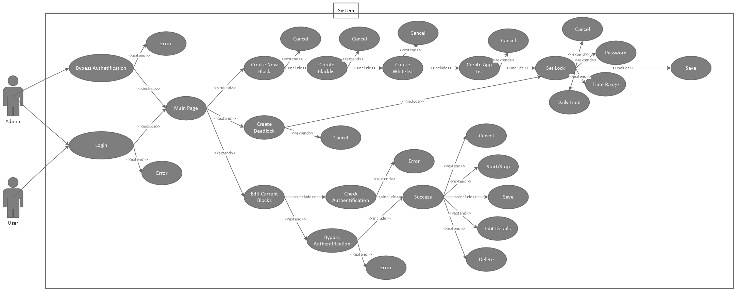

Use Case Name: Login
Actor(s) | Admin, User
Precondition | NA
Trigger | New Program Window Opened
Guarantee | That only owner can login into program
Description | When the program is first run, user is requested to login for safety reasons.
Data | Text (Password)
Response | - Success: Load program main page  - Failure: Error message  - Open “Get Help?” Window
Comments (notes) | The “Get Help?” window allows the Admin to enter their passwords to bypass authentication process

Use Case Name: Create Block
Actor(s) | Admin, User
Precondition | NA
Trigger | Clicking “Create New Block” Button
Guarantee | Block has a name
Description | Create new Block implementation window.  First page of creating a new Block: Naming  A Block consists of multiple other use-cases and pages:  - Create whitelist  - Create blacklist  - Create application list  - Set lock
Data | Text
Response | - Proceed: Move to create blacklist page  - Cancel: close new Block implementation window
Comments (notes) | Ensures that the new Block has a name. Won’t proceed otherwise.

Use Case Name: Create Blacklist
Actor(s) | Admin, User
Precondition | Block Name has been set
Trigger | Click “Proceed” on set Block Name page
Guarantee | NA
Description | Sets a blacklist of website URLs.
Data | Text (website URLs)
Response | - Back: Return to set Block Name page  - Proceed: Move to create whitelist page  - Cancel: close new Block implementation window
Comments (notes) | Typing * in the field will blacklist ALL website URLs

Use Case Name: Create Whitelist
Actor(s) | Admin, User
Precondition | - Block Name has been set  - Does not conflict with Blacklist of different Block (otherwise ignore)
Trigger | Click “Proceed” on create Blacklist page
Guarantee | NA
Description | Sets a Whitelist of website URLs.
Data | Text (website URLs)
Response | - Back: Return to create Blacklist page  - Proceed: Move to create Application list page  - Cancel: close new Block implementation window
Comments (notes) | Typing * in the field will whitelist ALL website URLs

Use Case Name: Create Application list
Actor(s) | Admin, User
Precondition | Block Name has been set
Trigger | Click “Proceed” on create Whitelist page
Guarantee | NA
Description | Sets a list of Applications the user wants to block
Data | Text (software name)
Response | - Back: Return to create Whitelist page  - Proceed: Move to set Lock page  - Cancel: close new Block implementation window
Comments (notes) | NA

Use Case Name: Set Lock
Actor(s) | Admin, User
Precondition | Block Name has been set
Trigger | Click “Proceed” on create Application list page
Guarantee | NA
Description | Sets a Lock Type
Data | - Text (Name of Lock Type)  - Radio Button (select Lock Type from choices)??
Response | - Opens new Lock Type Window depending on user input  - Back: Return to create create Application list page  - Save:  - Creates new Block object with all Block details  - Displays new Block on main page  - Cancel: close new Block implementation window
Comments (notes) | A Lock ensures that the Block is safe from edits while it is running

Use Case Name: Set Lock Type “Password”
Actor(s) | Admin, User
Precondition | - Block Name has been set  - User selected “Password” in setting lock type
Trigger | User selected “Password” in setting lock type
Guarantee | That Block is Locked using Password
Description | Lets user define a Password to Lock the Block
Data | - Enter new Password  - Verify Password
Response | - OK: Save Lock type and return to set Lock page  - Cancel: Terminate Lock type window without saving and return to set Lock page
Comments (notes) | NA

Use Case Name: Set Lock Type “Time Range”
Actor(s) | Admin, User
Precondition | - Block Name has been set  - User selected “Time Range” in setting lock type
Trigger | - User selected “Time Range” in setting lock type  - Clicked on proceed while setting Deadlock
Guarantee | That Block is Locked using Time Range
Description | Lets user define a Time Range to Lock the Block
Data | - Start time  - End time
Response | - OK: Save Lock type and return to set Lock page  - Cancel: Terminate Lock type window without saving and return to set Lock page
Comments (notes) | NA

Use Case Name: Set Lock Type “Daily Limit”
Actor(s) | Admin, User
Precondition | - Block Name has been set  - User selected “Daily Limit” in setting lock type
Trigger | User selected “Daily Limit” in setting lock type
Guarantee | That Block is Locked using Daily Limit
Description | Lets user define a Daily Limit to Lock the Block
Data | - Time measure (hours/minutes)  - Amount (e.g. 7 hrs)
Response | - OK: Save Lock type and return to set Lock page  - Cancel: Terminate Lock type window without saving and return to set Lock page
Comments (notes) | NA

Use Case Name: Get Help Window
Actor(s) | Admin
Precondition | NA
Trigger | Clicking “Get Help?” on any page that requires authentication of some sort
Guarantee | Admin can bypass authentication
Description | Allows the Admin to bypass authentication by typing 2 of 4 passwords correctly
Data | 4 Text fields - (Passwords)
Response | - Authorized: Bypass authentication  - Unauthorized Error
Comments (notes) | NA

Use Case Name: Create Deadlock
Actor(s) | Admin, User
Precondition | NA
Trigger | Click “Create New Deadlock” on main page
Guarantee | Deadlock is named
Description | - Create new Deadlock implementation window  - First page of window: Naming
Data | Text (Name)
Response | - Proceed: Opens new Lock type Time Range window  - Cancel: close new Deadlock implementation window  - Save:  - Creates new Deadlock object with relevant details  - Displays new Deadlock on main page
Comments (notes) | A Deadlock blocks the entire device for a specified time

Use Case Name: Edit Current Blocks
Actor(s) | Admin, User
Precondition | Has Authorization
Trigger | Click “Edit Current Blocks” on main page
Guarantee | NA
Description | Allows user to make changes to already implemented Blocks
Data | - Text (Block/Deadlock Name)  - Radio Button??
Response | - Start/Stop: change current state of Block  - Delete: Block  - Open Block/Deadlock implementation window
Comments (notes) | NA

Use Case Name: Uninstall Program
Actor(s) | Admin
Precondition | Has Authorization
Trigger | User attempting to uninstall program
Guarantee | Only Admin can uninstall
Description | Implements “Get Help?” automatically
Data | Text (Admin Passwords)
Response | - Authorized → uninstall program  - Error → Not Authorized
Comments (notes) | NA

Use-Case???

Use Case Name: Check Authorization
Actor(s) | Admin, User
Precondition | NA
Trigger | User attempting to make changes to an existing Block
Guarantee | NA
Description | Checks if the user is authorized to make changes to an existing Block
Data
Response | Does the following checks in this order:  isAuthorized == False  isLocked == True {  lockType == Password {  open new window requesting user to enter password  if passwordIsCorrect {  return isAuthorized = True  } else {  Error  }  } else if blockIsRunning = True {  return isAuthorized  } else {  return isAuthorized = True  }  }
Comments (notes) | NA

